

**Polling District and Polling Place Review 2025**

**Jesmond Ward**

**Parliamentary Constituency:** North

**(Proposed) Polling Districts:** M01, M02, M03, M04, M05, M06

The Local Government Boundary Commission for England are an independent body accountable to Parliament. They are responsible for reviewing councils to make sure their patterns of internal wards are fair and sensible. Their reviews include at least two rounds of public consultation before they make recommendations for change.

The final recommendations were published on 7 January 2025, and the new arrangements apply to local elections from 2026.

As a result of changes to ward boundaries the Acting Returning Officer (ARO) is conducting a review of polling districts and polling places to ensure that they are suitable for the new ward boundaries.

For more information on the local government boundary review visit: <https://www.lgbce.org.uk/all-reviews/newcastle-upon-tyne>

This document provides details of the review, along with the initial recommendations and comments of the Acting Returning Officer (ARO). Also, the election rules require the ARO to decide how many polling stations are required for each polling station and the ARO must allocate electors to the polling stations in such manner as they think most convenient.

These recommendations will be open to all residents, stakeholders, and any interested parties. We shall be seeking representations from local disability groups on the accessibility and suitability of polling places. Any comments should be addressed in the first instance to pollingplaces@newcastle.gov.uk where they will be collated on behalf of the (Acting) Returning Officer.

We considered the following factors:

* **Identifying new polling places:** We will look for new polling places in areas where the existing provision is unsuitable or unavailable.
* **Feedback:** We will consider feedback received following recent elections, consultation from members of the public, elected members, and other stakeholders.
* **Accessibility:** We will try to ensure that every polling place is accessible to electors with disabilities.
* **Facilities**: We will make sure that all electors have such reasonable facilities for voting as are practicable in the circumstances.
* **Elector numbers:** We will try to comply with the Electoral Commission guidance on the maximum number of electors that should be allocated to a polling station which should not exceed 2,250.
* **Future housing developments**: We will consider the impact of proposed housing developments on polling station electorates.

**(Current) North Jesmond Ward**

This map shows the current ward and polling district boundaries and the polling places.

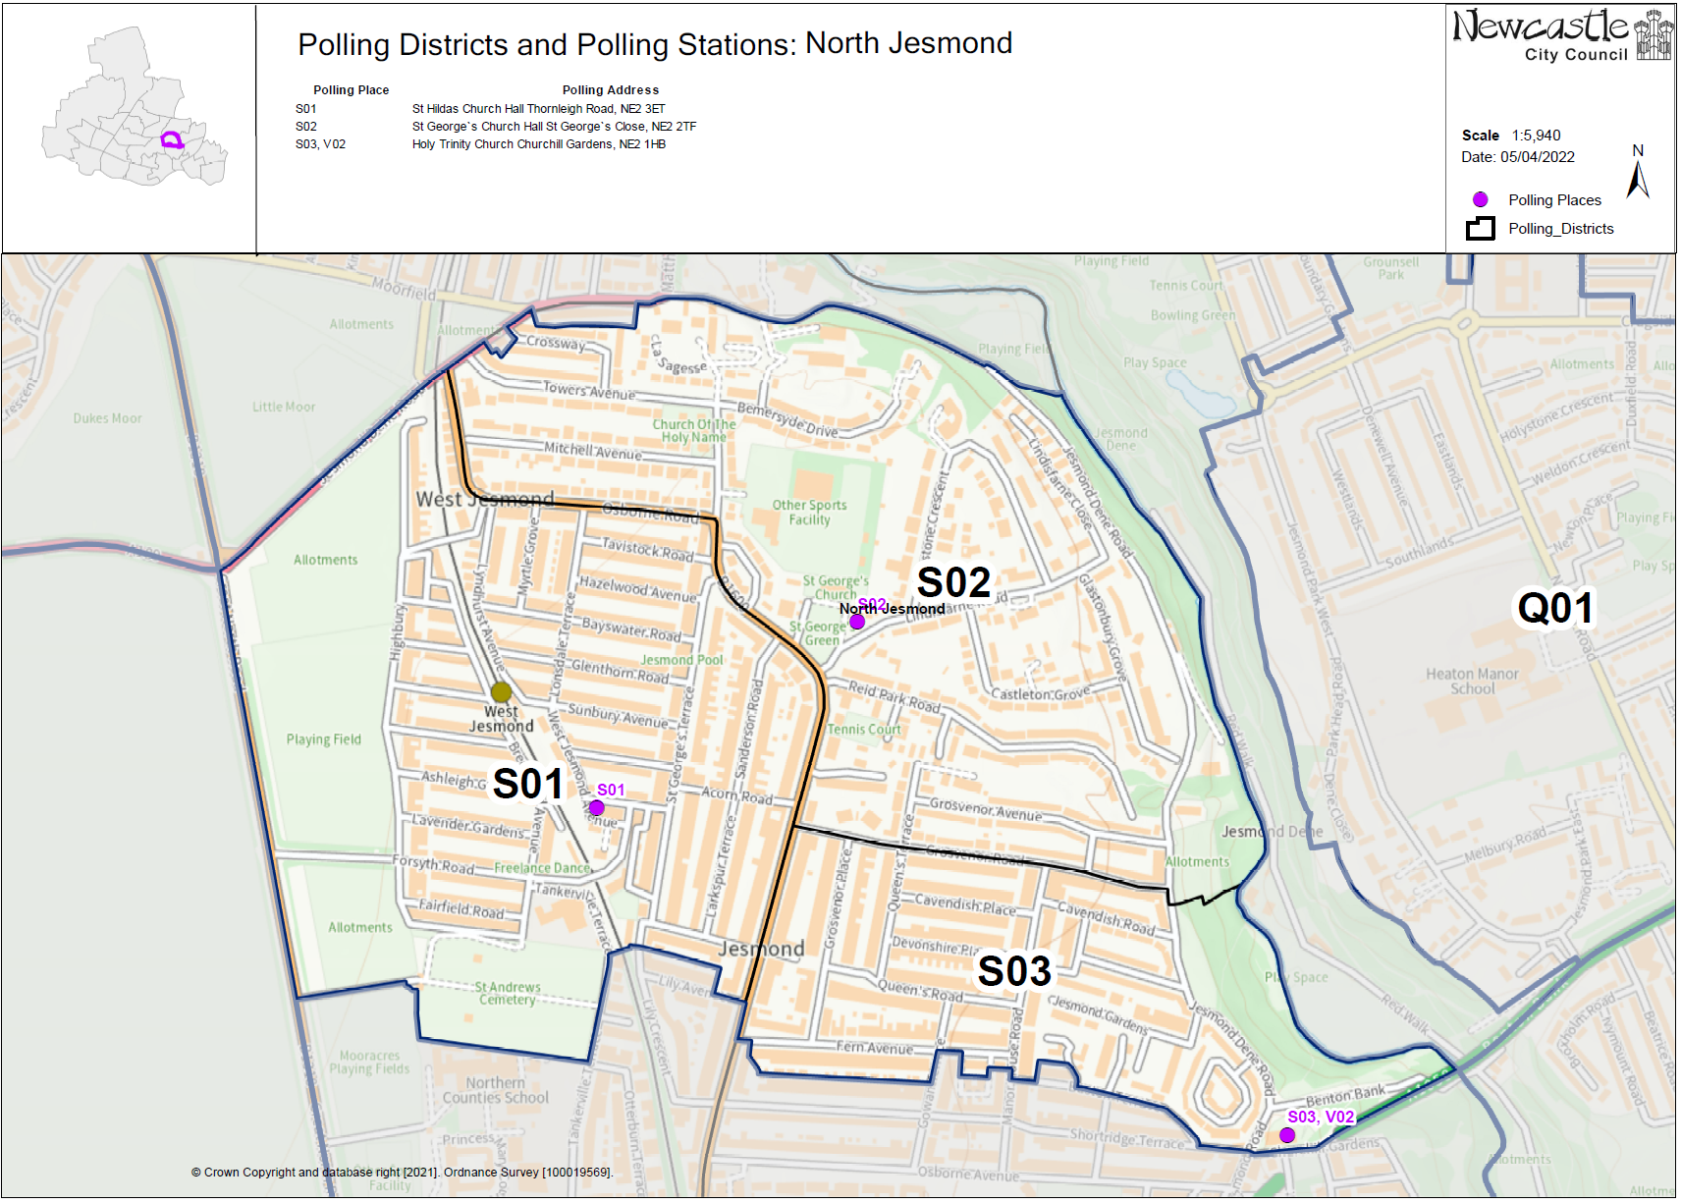

**(Current) South Jesmond Ward**

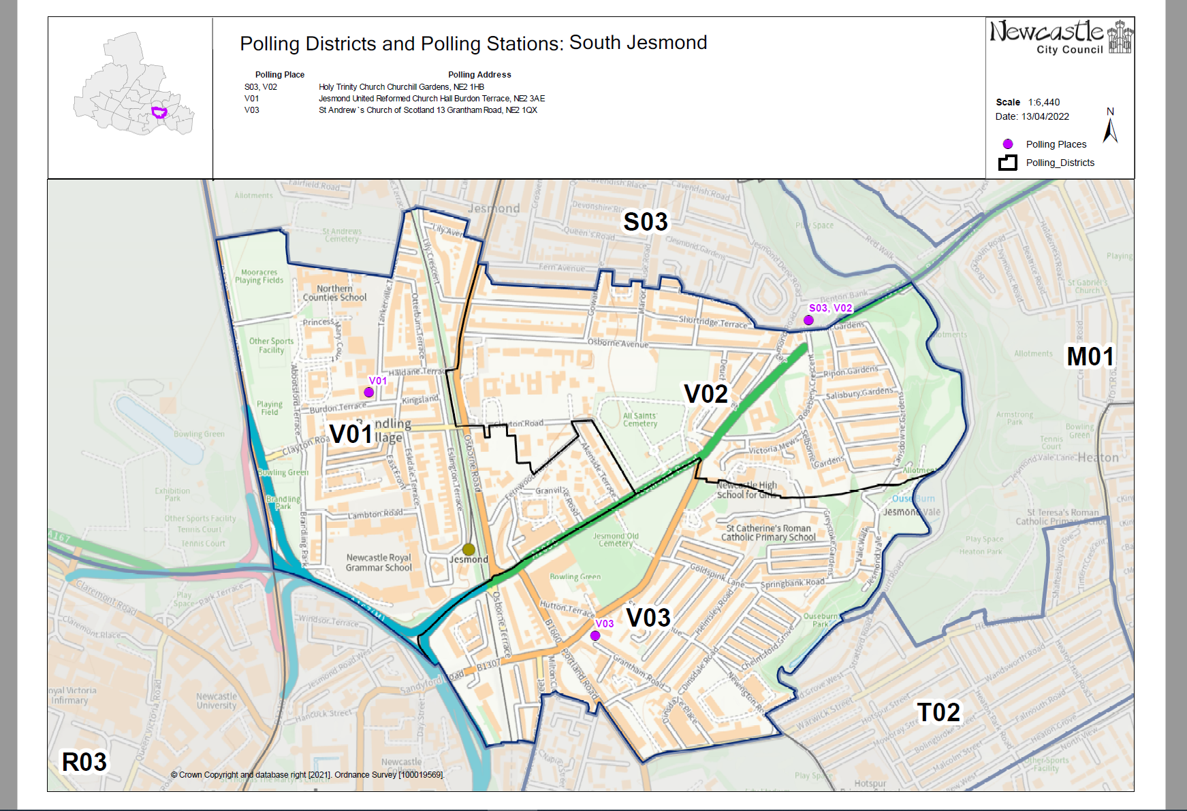

**(New)**

**Jesmond Ward**

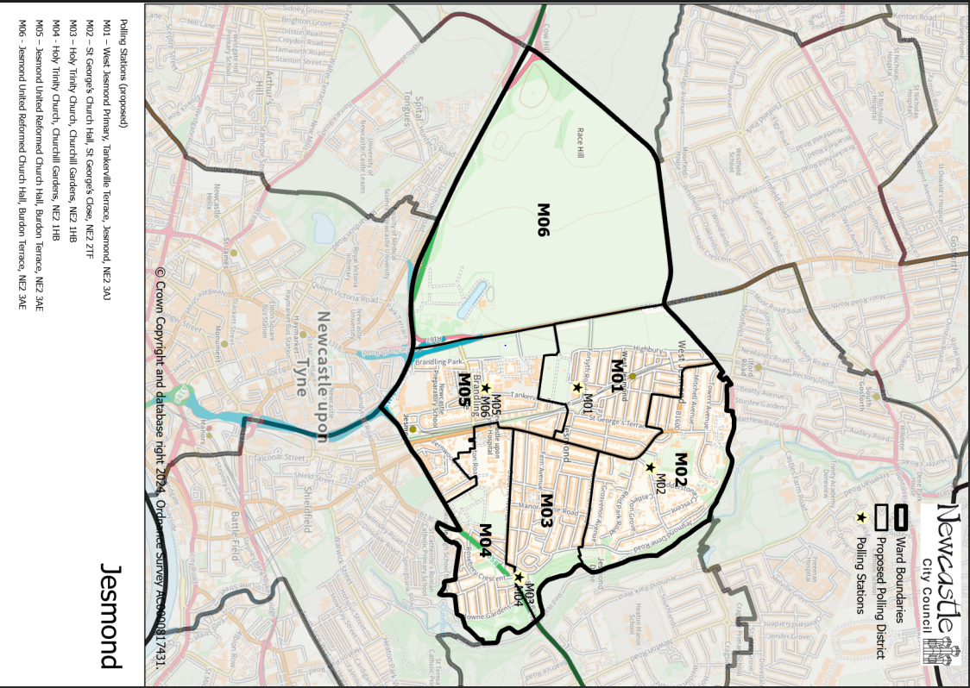

This map shows the new ward and the proposed polling districts and the proposed polling places.

* **M01** – West Jesmond Primary, Tankerville Terrace, Jesmond, NE2 3AJ
* **M02** – St George’s Church Hall, St George’s Close, NE2 2TF
* **M03** – Holy Trinity Church, Churchill Gardens, NE2 1HB
* **M04** – Holy Trinity Church, Churchill Gardens, NE2 1HB
* **M05** – Jesmond United Reformed Church Hall, Burdon Terrace, NE2 3AE
* **M06** – Jesmond United Reformed Church Hall, Burdon Terrace, NE2 3AE

**Jesmond Ward**

**Polling District M01**

|  |  |
| --- | --- |
| **Current Polling District** | **Current Polling Place** |
| S01 (part of) | St Hilda’s Church Hall, Thornleigh Road, NE2 3ET |

|  |  |  |
| --- | --- | --- |
| **Proposed Polling District** | **Predicted**  **Polling Station Electorate** | **Proposed Polling Place** |
| M01 | 1400 | West Jesmond Primary, Tankerville Terrace, Jesmond, NE2 3AJ |
|  | | |

|  |
| --- |
| **Considerations and Proposals** |
| Part of the current S01 would become the proposed M01 district. Loses a small part of the district to the proposed M02 district.  West Jesmond Primary school is within the proposed M01 district, however, so is St Hilda’s Church, so both buildings could be considered as suitable suggestions to be used as polling stations. Site visit required to West Jesmond Primary. |
|  |

|  |
| --- |
| **Preliminary Consultation – Elected Members comments and feedback** |
| No comments received. |

**Jesmond Ward**

**Polling District M02**

|  |  |
| --- | --- |
| **Current Polling District** | **Current Polling Place** |
| S01 (part of)  S02 (full) | St Hilda’s Church Hall, Thornleigh Road, NE2 3ET  St George’s Church Hall, St George’s Close, NE2 2TF |

|  |  |  |
| --- | --- | --- |
| **Proposed Polling District** | **Predicted**  **Polling Station Electorate** | **Proposed Polling Place** |
| M02 | 1060 | St George’s Church Hall, St George’s Close, NE2 2TF |
|  | | |

|  |
| --- |
| **Considerations and Proposals** |
| The current S02 district takes on a small section of the current S01 which would become the proposed M02 district.  St George’s Church Hall is the suggested polling station for the proposed M02 district. |
|  |

|  |
| --- |
| **Preliminary Consultation – Elected Members comments and feedback** |
| No comments received. |

**Jesmond Ward**

**Polling District M03**

|  |  |
| --- | --- |
| **Current Polling District** | **Current Polling Place** |
| S03 (full)  V02 (part of) | Holy Trinity Church, Churchill Gardens, NE2 1HB  Holy Trinity Church, Churchill Gardens, NE2 1HB |

|  |  |  |
| --- | --- | --- |
| **Proposed Polling District** | **Predicted**  **Polling Station Electorate** | **Proposed Polling Place** |
| M03 | 1305 | Holy Trinity Church, Churchill Gardens, NE2 1HB |
|  | | |

|  |
| --- |
| **Considerations and Proposals** |
| Merge current S03 district and a small part of current V02 to create the proposed M03 district. Properties to the north of Osborne Avenue, would now form the proposed M03 district.  No change to the polling place. Holy Trinity Church is suggested as a double polling station for the proposed districts M03 and M04. |
|  |

|  |
| --- |
| **Preliminary Consultation – Elected Members comments and feedback** |
| No comments received. |

**Jesmond Ward**

**Polling District M04**

|  |  |
| --- | --- |
| **Current Polling District** | **Current Polling Place** |
| V02 (part of)  V03 (part of) | Holy Trinity Church, Churchill Gardens, NE2 1HB  St Andrew’s Church of Scotland, Grantham Road, NE2 1QX |

|  |  |  |
| --- | --- | --- |
| **Proposed Polling District** | **Predicted**  **Polling Station Electorate** | **Proposed Polling Place** |
| M04 | 836 | Holy Trinity Church, Churchill Gardens, NE2 1HB |
|  | | |

|  |
| --- |
| **Considerations and Proposals** |
| Most of the current V02 district and a small part of the current V03 district would become the proposed M04 district. Properties south of Osborne Avenue, would now form the proposed M04 district.  No change to the polling place. Holy Trinity Church is suggested as a double polling station for the proposed districts M03 and M04. |
|  |

|  |
| --- |
| **Preliminary Consultation – Elected Members comments and feedback** |
| No comments received. |

**Jesmond Ward**

**Polling District M05**

|  |  |
| --- | --- |
| **Current Polling District** | **Current Polling Place** |
| V01 (full) | Jesmond United Reformed Church Hall, Burdon Terrace, NE2 3AE |

|  |  |  |
| --- | --- | --- |
| **Proposed Polling District** | **Predicted**  **Polling Station Electorate** | **Proposed Polling Place** |
| M05 | 1161 | Jesmond United Reformed Church Hall, Burdon Terrace, NE2 3AE |

|  |
| --- |
| **Considerations and Proposals** |
| Current V01 would become the proposed M05. No change to the polling district boundary.  No change to the polling place.  Jesmond United Reformed Church is suggested as a double polling station for the proposed districts of M05 and M06. |

|  |
| --- |
| **Preliminary Consultation – Elected Members comments and feedback** |
| No comments received. |

**Jesmond Ward**

**Polling District M06**

|  |  |
| --- | --- |
| **Current Polling District** | **Current Polling Place** |
| Z05 (part of) | Spital Tongues Community Centre, Morpeth Street, NE2 4AS |

|  |  |  |
| --- | --- | --- |
| **Proposed Polling District** | **Predicted**  **Polling Station Electorate** | **Proposed Polling Place** |
| M06 | 0 | Jesmond United Reformed Church Hall, Burdon Terrace, NE2 3AE |

|  |
| --- |
| **Considerations and Proposals** |
| This would be a new district. Most of current Z05 would become the proposed M06 district.  Currently non-residential area.  Jesmond United Reformed Church is suggested as a double polling station for the proposed districts of M05 and M06. |

|  |
| --- |
| **Preliminary Consultation – Elected Members comments and feedback** |
| No comments received. |